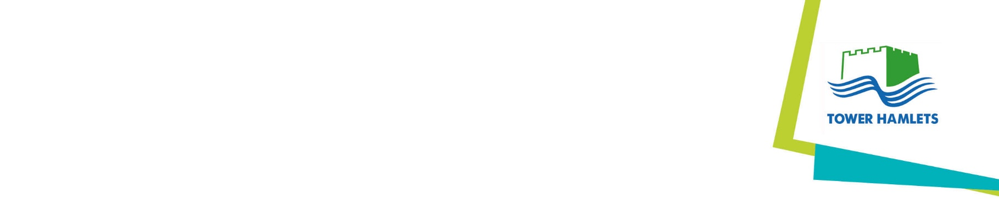
Tower Hamlets Full Headteacher Consultative

OUR PLEDGE:
The Headteachers of Tower Hamlets schools are committed to supporting and addressing the actions outlined in the Inequality Race Commission Report (18th March 2021). We will work with our partners such as the Local Authority, Tower Hamlets Education Partnership and beyond, to strengthen our approach and therefore our impact towards reducing inequality now and for generations to come. As Headteachers in this vibrant and diverse borough, the longstanding power of our collaboration and support for each other is the foundation to our magnitude of successes. Now, more than ever, is the time to invest this power in making our borough stand stronger in solidarity against discrimination, actively strive to be more equal, more inclusive and even richer because we maximise talent within our Black and Ethnic Minority community.
We consider that all manifestations of inequality are wholly unacceptable and will act positively to eliminate discrimination where it occurs and to promote equality of opportunity between people who share a protected characteristic and people who do not share it. We will take prompt, effective and systematic action to deal with all discriminatory incidents and to identify and address inequalities arising from discrimination.
In unity, we will work together to champion the brilliance of our Black and Ethnic Minority community and make a tangible difference to reduce inequalities in our borough both now and for the future.
We also commit ourselves to the aims of the Tower Hamlets corporate pledge.
School specific activities
We know our pledge needs to be underpinned by significant actions. In the initial stages, our school has, or is actively working towards:
- Engaging / participating in a working party scoping a leadership programme aimed at increasing the number of Black, Asian and Minority Ethnic teachers in Head and Deputy Head roles.
- Auditing our practice within schools and identifying the key improvement areas
- Understanding and actively supporting the overall aims through for example, local area data, recruitment and training
- Finding best practice across the country
- Sharing our own good practice between schools
- Taking part in an anti-racist curriculum project with Global Learning London to ‘decolonise’ the curriculum and establish the difference between non-racism and racism, and what that means in a school setting.
- All involved in recruitment of governors to undertake unconscious bias training.

We are committed to producing an (updating our) Equalities Action Plan by the end of 2022 in alignment with and informed by the activities above. This will be brought to the full Governing Body for approval in the next six months and published on our website.

